Friday June 24th, 2022  5:00pm-Community BBQ starts  6:00pm-3 on 3 Basketball Tourney-(9th grade and older)  9:00pm-Glow Dash Run/Walk  All events for adults:  $10.00 for pre-registration, $12.00 day of event.  All events for kids under 17, $5.00 for pre-registration, $7.00 day of event  All registration forms can be picked up at the Hanna Recreation Center  Youth 3 on 3  If you pre-register for all events you will receive a King Coal Days 2022 Tee Shirt (excludes parade participants)  Bounce Houses will be up for kids to enjoy $5.00 wrist bands to play all day!  older)  7:00pm-9:00pm-Karoke under the Big Tent  9:00pm-Glow Dash Run/Walk | Saturday June 25th, 2022  8:00-10am-Hanna Fire Department-Pancake Breakfast  9:00am-Noon-  Food Vendor/Craft Show/Silent Auction-SET-UP  10:30am Parade line up at Hanna Town Hall  (301 S. Adams)-Will include Car Show Vehicles  11:00am-Parade Begins at Town Hall and ends at the Hanna Rec Center  Noon-5pm  Vendor/Craft Show and Silent Auction items displayed  Food Vendors will be ready Kids Games and Races will start at 12:30pm on front lawn of Rec Center on June 25th.  Car Show line-up in Parking lot after parade  Judging will start at 12:30, prizes for Best in Show, Most Original and People’s choice. | Saturday June 25th, 2022  12:30pm-1:00pm-  3-Legged Races  1:00pm-1:30pm-  Water Balloon Toss  1:30pm-2:00pm-Human Wheel Barrow Races  2:00pm-2:30pm-Gunny Sac Races  2:30pm-3:00pm-  Egg Spoon Race  3:00pm-3:30pm  Watermelon Eating Contest  3:30pm-Money Pit-  (coins will be hidden in the Volleyball Sand Pit)  4:00pm-Sand Volleyball Tournament  4:00pm-  Doubles Horseshoe Tournament  5:00pm-Community Dinner starts  4pm-9pm Music and Dancing  Nominate someone for Parade Marshal For more info Contact the Rec Center at  307-325-9402 or rec@townofhanna.com | KING COAL DAYS  June 24th and June 25th, 2022  ALL EVENTS AT THE HANNA RECREATION CENTER 8000 HWY 72 HANNA WY. 82327  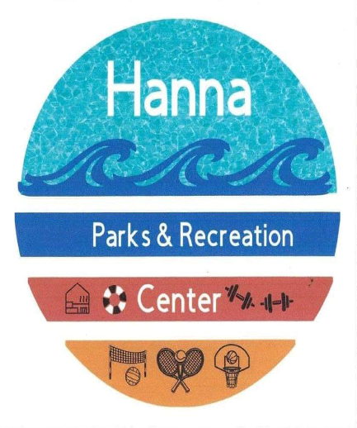  A family fun event with music, food, games and prizes, put on in part by local businesses, Town of Hanna and Rec Center  s

